ID : 24179

Names: MPUNDU Guy Corneille

# Coffee menu management

**Project Requirements**:

1. Project Purpose:

The primary purpose of the project is to develop a comprehensive menu management system for a coffee shop.

1. Expected outcomes:

* Efficient management of the coffee shop menu.
* Easy addition and removal of menu items.
* Categorization of menu items for better organization.
* Clear display of the menu for customers, possibly through a user-friendly interface.

**Project plan**:

1. Scope of the Project:

The system will cover the entire menu management process, including adding, updating, and deleting menu items, categorizing items, and displaying the menu to customers.

1. Timeline:

The project timeline was 2 weeks as the requirement were to be given by ourselves to choose the area to work on.

1. The resources :

* Human resources: Me
* Technological resources:

Dev tools: Intellij IDE

Framework and libraries: Spring boot for java

Database: MySql

Frontend: HTML&CSS

Backend: Java

**Database Schema:**

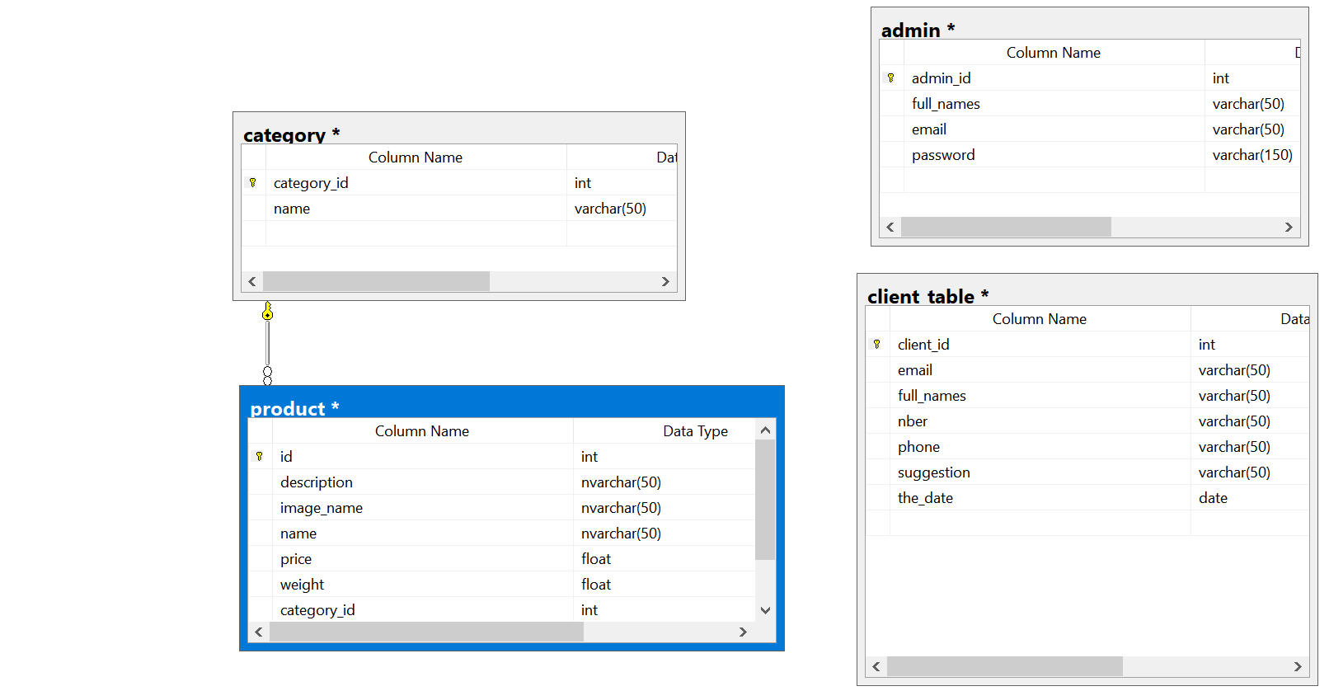

**User documentation:**

The system is very easy to use :

* The user will press Login and will either login or create a new user. Once done it will redirect to the admin / staff page
* The rest is straight forward press the button for action